

|  |
| --- |
| Test Case  Sprint 3 |
|  |
| 11/06/21 - 18/06/21  ICED COFFEE  Authored by: Bayley Wise and Kyle Chamberlain |

# 2,759 Iced coffee Vectors, Royalty-free Vector Iced coffee Images | Depositphotos®

Contents

1

Rate Movies 3

Admin Log-in 4

# Rate Movies

|  |  |  |  |
| --- | --- | --- | --- |
| Test # | Input | Expectations | Results |
| 1 | Rate movie | Movie rating is added to database | As expected.  Figures 1 and 2 |
| 2 | Rate same movie | Average is changed. | As expected.  Figures 3 and 4 |
| 3 | Rating top 10 | Rating top 10 table displays. | As expected.  Figure 5 |
| 4 | Select different date | Different table displays. | As expected.  Figure 6 |
| 5 | New top 10 | New top 10 is added to database if its different to the previous one. | As expected.  Figures 6 and 7 |

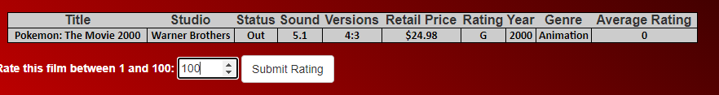

Figure



Figure

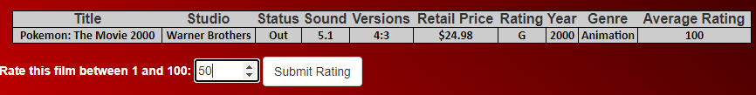

Figure



Figure

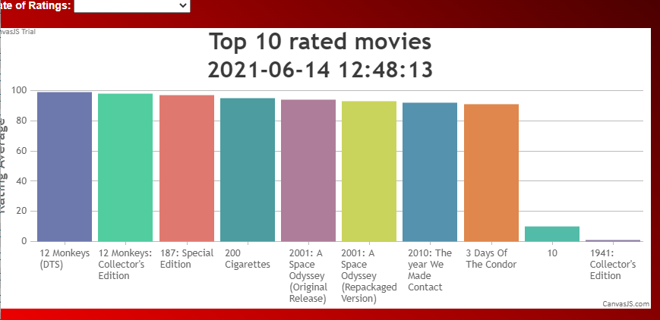

Figure

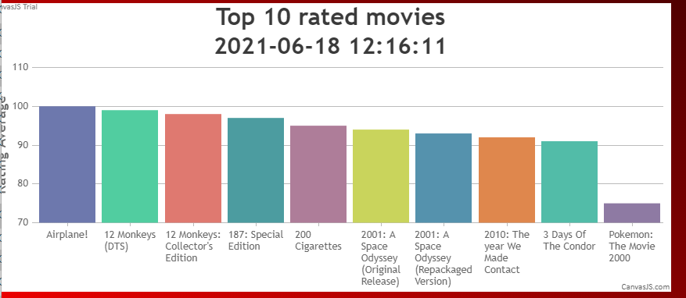

Figure



Figure

# Admin Log-in

|  |  |  |  |
| --- | --- | --- | --- |
| Test # | Input | Expectations | Results |
| 1 | Correct Username and Password. | The user will be taken to the view all users page | Expected. The page being displayed straight after is the show users page. |
| 2 | Incorrect Username and password | The page will reload with a user friendly error message | Expected. A friendly error is shown. |
| 3 | Correct Username but incorrect password. | The page will reload with a user friendly error message |  |
| 4 | Incorrect Usename but correct password | The page will reload with a user friendly error message |  |
| 5 | Password complexity test | Only password with at least 1 capital, 1 number , 1 lowercase and 1 special character pass the test. | Figure 8. Passed |

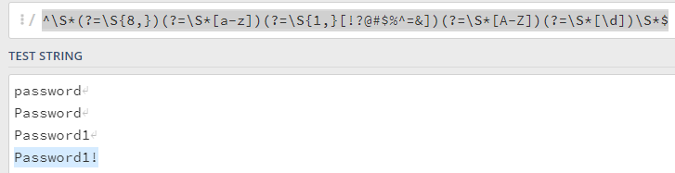

Figure